**2.1 I can describe the purposes for using collaborative technologies**

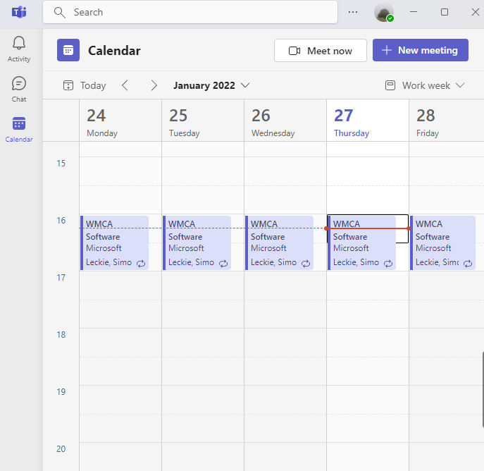There are a number of technologies which can be used to collaborate. From my view, if the means of using the technology is to meet and collaborate, I feel that [Microsoft Teams](https://www.microsoft.com/en-gb/microsoft-teams/group-chat-software) is very good and is getting better. I feel it has a number of valuable features, such as the calendar function which easily synchronises with Outlook:

It is also entirely free, it has a good messaging and meeting system, meeting participants can have cameras on, and control in meetings can be easily transferred. Indeed, the fact that my workplace (the regulator of Solicitors in England and Wales) choose to use it also shows its capabilities. Teams is already good at what it does I feel, and it’s getting regular updates as Microsoft install new features into it. Recently for example they have added a whiteboard feature. More information is available at <https://support.microsoft.com/en-us/office/microsoft-whiteboard-help-d236aef8-fcdf-4b5e-b5d7-7f157461e920>.

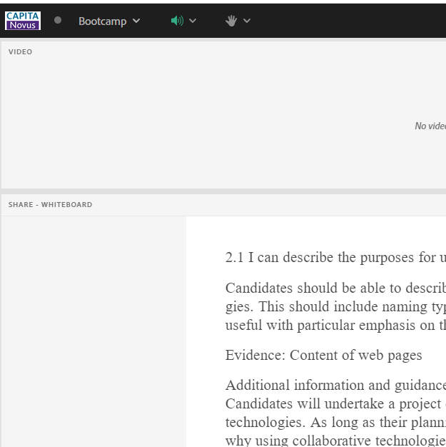There are other similar applications which can be used to communicate/ collaborate, [Adobe Connect](https://www.adobe.com/uk/products/adobeconnect.html) being one of them. Adobe Connect, whilst it can do some of what Teams can do, has a number of drawbacks. It is not free to download/use, and meeting participants cannot be seen. It has a filing system which is slightly more intuitive but the one in Teams is not bad and the other benefits outweigh what Adobe can offer, for me at least.

When collaborating informally, there are many suitable and free applications which can be used to converse with one another. These include WhatsApp, Facebook Messenger, Zoom, and Discord. Many include the option to see who you are talking to, send/ receive and react to messages, and exchange files.